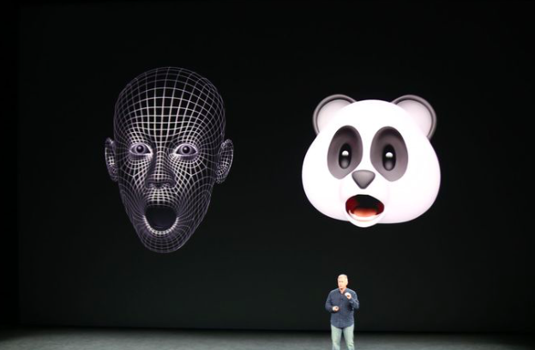

Customer and Investors Sentiments – Apple

Vinod Joshi (11810037) | Meenakshi Naren (11810030)

28-Dec-2018

# Executive Summary

This report provides an analysis of the current customer and investor sentiment about Apple Inc. based on the close observation of their flagship product iPhone. iPhone contributes to approximately 60% of the Apple’s revenue[1], hence the methods of analysis includes a close observation of iPhone sales trend, compete, stock price, service consumption, news, consumer sentiments and comparative of peers from the same sector. All the datasets can be found in the appendices. Results of the analysis show that the recent plunge in Apple’s performance reflects a systematic decline in the sector as opposed to any concrete resemblance of the customer or investor sentiment about the company.

The report finds that Apple Inc. still demonstrates a healthy performance of its flagship product and any inference to its performance would be too early a call.

The report also investigates the fact that the analysis conducted has limitations. Some of the limitations includes:

non-availability of geographic distribution of iPhone sales, lack of age-group based sales distribution, limited information about OnePlus Stock information (a compete that is gowning rapidly but privately held) and App Store data for trend of the services consumption.

# Business Problem

# Introduction

Apple Inc. has seen a phenomenal growth in the last decade esp. with the launch of its flagship product called iPhone. While Apple Inc. has been in various businesses, iPhone has been the primary revenue generator for the company. As much that between 2014- 2016, iPhone contributed to approximately 70% of the Apple’s Revenue. In the 4th quarter of 2018 iPhone still has 60% of the share of Apple revenue, thus in a way Apple could be called an iPhone company.

In the last six months Apple has been in news for various reasons, including the change in unit sales reporting, potential 10% tariff that could be imposed by the incumbent government, the US China trade war and above all some skepticism about Apple’s future based on the perceived dearth of innovative products in the last few years.

In our analysis we closely observed iPhone, the flagship product for Apple to build our hypothesis about the consumer and investor sentiment about Apple Inc.

# Methodology

# Appendix

[1]

